A320 PRO PLUS

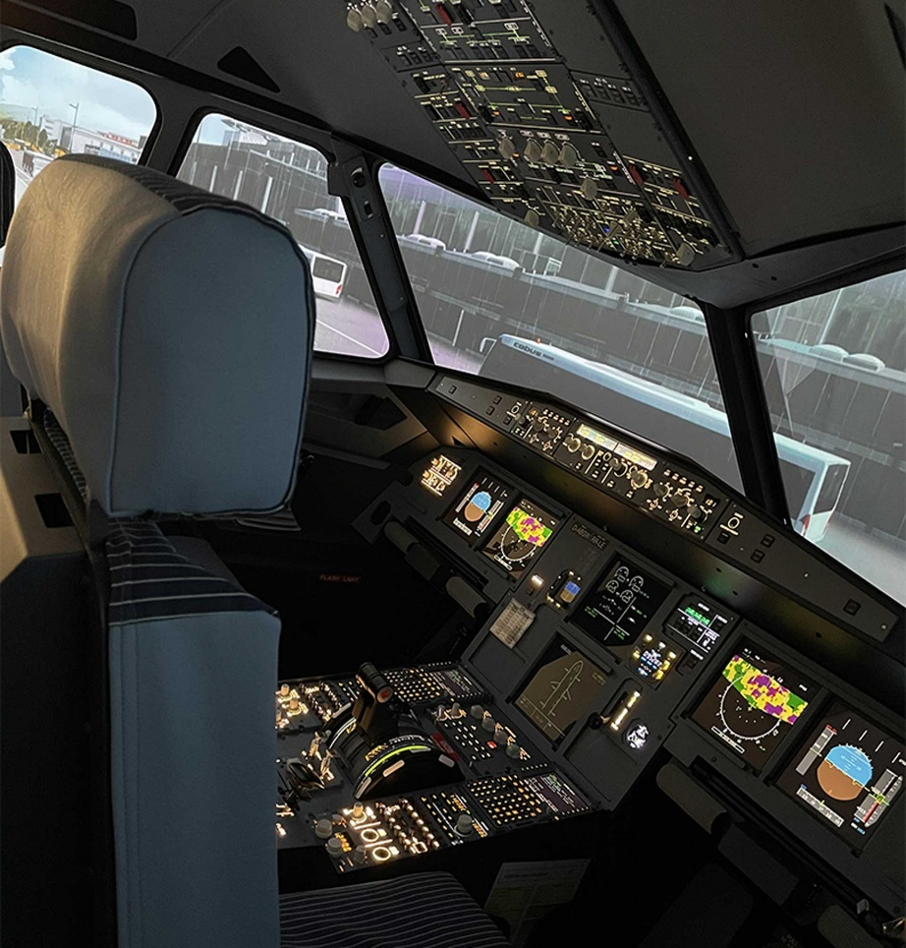

## A320 Pro Lite Base

Get all the incredible features of our A32X Pro Lite, to which we add several elements of realism, training, and precision.

## Rear Instructor Station

Get access to the Instructor Station on our articulated arm, for rear position management. Let your customers train in real-life conditions, and give the instructor the chance to conveniently plan & execute the training scenarios.

## Worldwide shipping & installation included.

Wherever you are in the world, we have your back. All shipping & Installation costs are included in our Pro Plus package. From our factory in Germany to your door.

## HQ 220° Wrap Around Screen

Our High-Quality seamless screen, brings you a 220° eld of view, with a perfectly circular view for the most realistic and stunning visual experience.

## Electrical Seats

Adjust the height of the seats electrically, so your point of view is located exactly where it should, for a precise and comfortable ying experience.

## 1 Year of updates included

Get regular updates to the navigation data and systems software during the rst year, free of charge.

## Pro Rudders

Get our Pro Rudders, which bring a more realistic design, resistance feeling, with an adjustable depth to suit your ying position.

## 10h Onsite training & extended service

We double the onsite training time we provide to your team, covering all aspects from technical questions to aircraft-speci c rules. Get access to additional resources to keep the simulator up to date throughout the years.

## The best investment for your business

With a cost-controlled high-end simulator, you have everything you need to run your operations: as a training center, simulation center, or as a demanding enthusiast.

**A320 Pro Lite**

* A320 Pro Shell & Cockpit Professional Licences
* Calculators & Projection System
* Mobile Instructor Station
* Delivery & Installation within Europe included
* 5 Hours of Onsite Training
* HQ 220° Projection Screen
* Worldwide Shipping & Installation (extra)
* Pro Rudders
* Electrical Seats
* Certification to a FNPTII MCC EASA Simulator

**A320 Pro Shell**

* A320 Pro Shell & Cockpit Professional Licences
* Calculators & Projection System
* Mobile Instructor Station
* Delivery & Installation within Europe included
* 5 Hours of Onsite Training
* HQ 220° Projection Screen
* Worldwide Shipping & Installation (extra)
* Pro Rudders
* Electrical Seats
* Certification to a FNPTII MCC EASA Simulator
* HQ 220° Projection Screen
* Rear position Instructor Station Setup with mobility
* 10 Hours of Onsite Training
* Worldwide delivery & installation included
* 1 Year of updates included
* Certification to a FNPTII MCC EASA Simulator

**A320 FNPTII MCC EASA**

* A32X Pro Shell & Cockpit
* Pro Rudders & Electrical Seats
* Hardware Upgrades
* Professional Licences
* Calculators & Projection System
* HQ 220° Projection Screen
* Rear position Instructor Station Setup with mobility
* 10 Hours of Onsite Training
* Worldwide delivery & installation included

**Email:** [**sales@kambillsystems.com or**](mailto:sales@kambillsystems.com) [**service@kambillsystems.com**](mailto:service@kambillsystems.com)

**Office Address: -Kambill Systems Private Limited**

**202, Aggarwal Corporate Heights, Netaji Subhash Place, Delhi=110034, INDIA.**

**Tel: +91-11-4903 2678 | +91-9650448007.**

**Website:** [**www.kambillsystems.com**](http://www.kambillsystems.com/)